
GETTING STARTED WITH
Claude
An adoption guide: products, models, plans, and first steps

Prepared by Syrv.ai
VERSION 1.0 · JUNE 2026

Contents
1. Introduction: What Is Claude?
2. The Claude Product Family — Claude, Cowork & Code
3. The Claude Models: Opus, Sonnet & Haiku
4. Claude Code: The TUI vs. the App
5. Permissions & Controls
6. Plans & Pricing
7. Getting Started
8. Quick Decision Guide
9. Resources & Sources

1. Introduction: What Is Claude?
Claude is a family of AI assistants built by Anthropic. You work with Claude through a few different products, each suited to a different kind of task: a chat assistant for everyday questions, an agent that completes multi-step work on its own, and a coding tool that reads and edits a whole software project.
Syrv put this guide together to help your team adopt Claude with confidence. It covers the three products (Claude, Claude Cowork, and Claude Code), the models behind them (Opus, Sonnet, Haiku, and the Fable flagship), the plans and pricing, the permission and admin controls, and a short walkthrough to get you started.
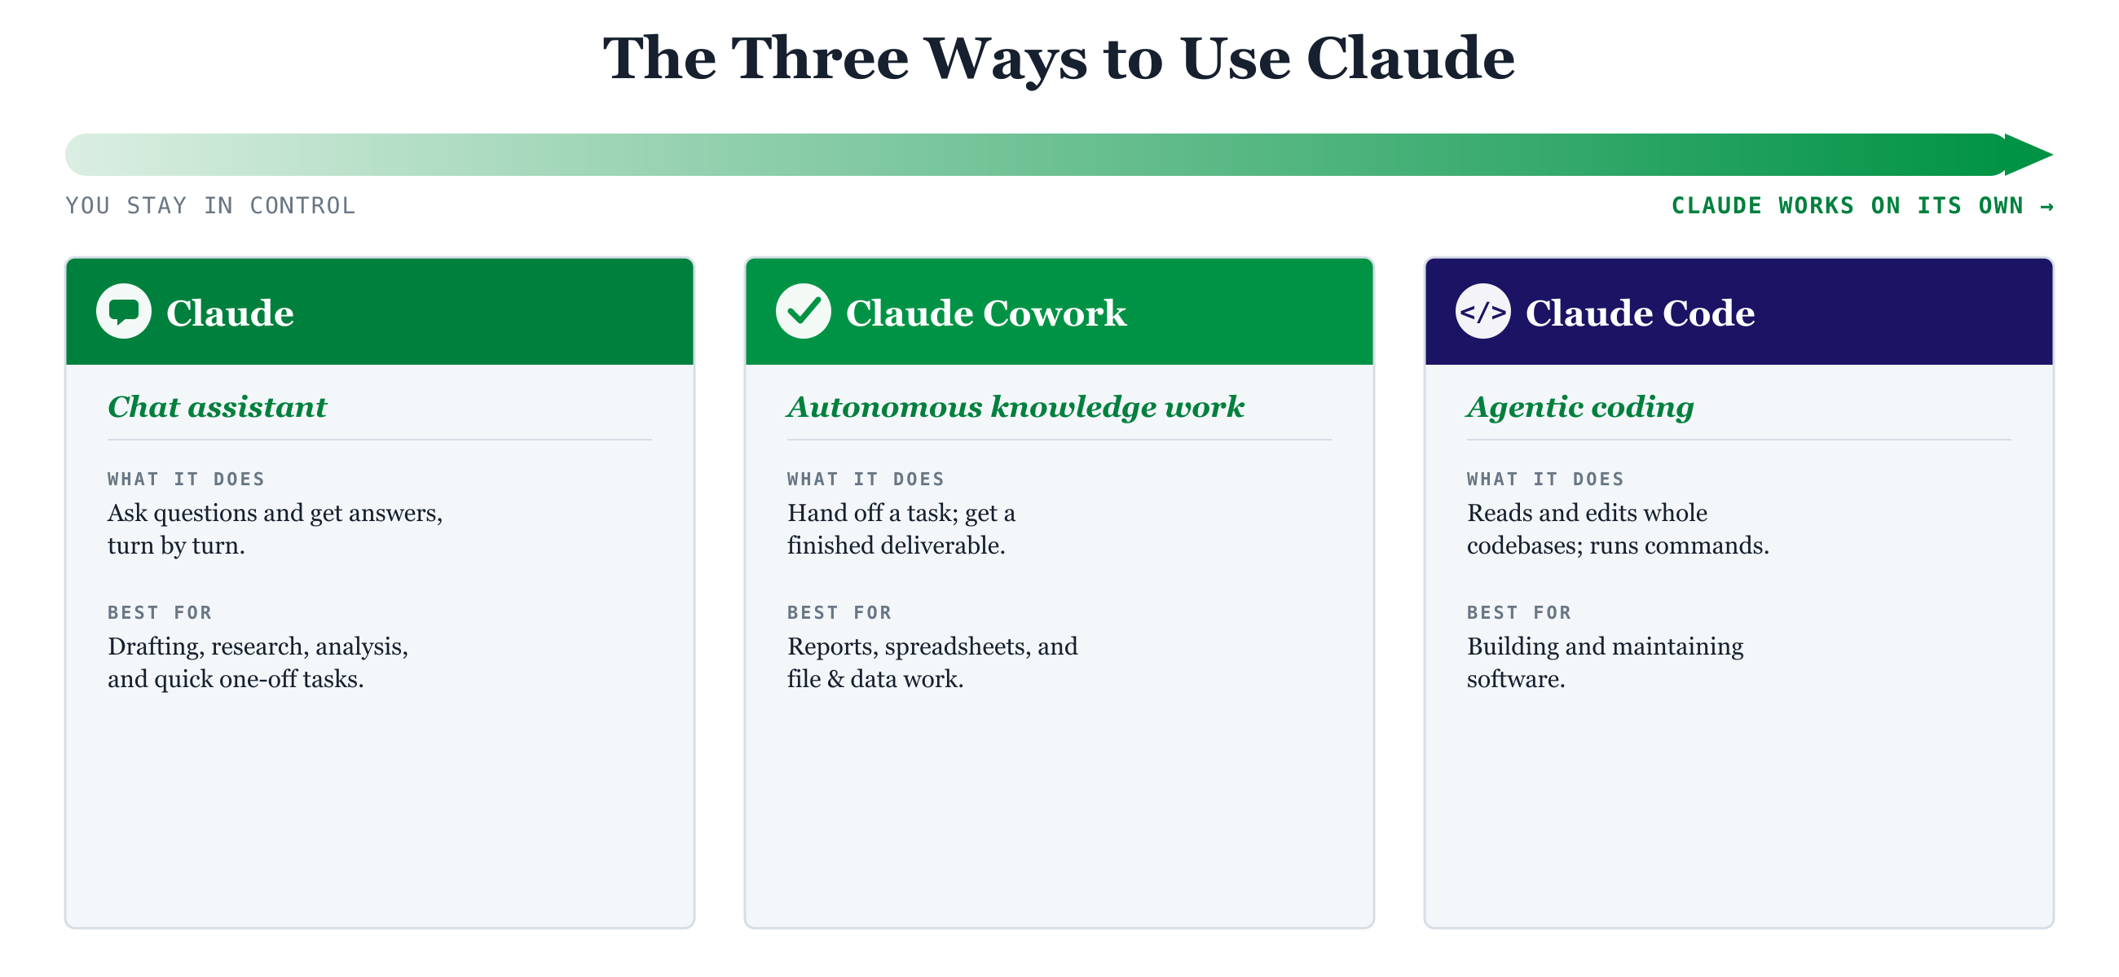
The three ways to use Claude, arranged by how much autonomy you hand over.
All three run on the same Claude models. What sets them apart is how you work with Claude and how much you hand off: a conversation, a delegated task, or a coding agent.

2. The Claude Product Family

2.1 Claude (the chat assistant)
Claude.ai is the conversational assistant most people start with. It runs in a web browser, as a desktop app for macOS and Windows, and on iOS and Android. You ask a question or give an instruction and Claude replies. It can search the web, read files you upload, analyze images, write and run code, remember context across a Project, and connect to tools such as Google Drive, Slack, and Microsoft 365 through connectors.
It suits drafting and editing, research, analysis, brainstorming, and quick questions where you want to stay in the loop on every step.

2.2 Claude Cowork
Claude Cowork applies that same autonomy to everyday knowledge work that has nothing to do with code. Rather than a back-and-forth chat, you describe the outcome you want and Cowork does the work: organizing files, building and formatting spreadsheets, pulling data out of documents or screenshots, preparing reports, and handling recurring tasks on a schedule. It runs in the Claude desktop app, works with your local files and apps, can navigate a browser, and checks with you before any significant action.
Cowork vs. Chat vs. Code
vs. Chat — Chat guides you step by step; Cowork completes the work autonomously and returns the finished result.
vs. Code — Claude Code targets software in the terminal/IDE; Cowork applies the same autonomy to office and knowledge work.
Availability — included on all paid plans (Pro, Max, Team, Enterprise); not on the Free plan.

2.3 Claude Code
Claude Code is Anthropic's coding agent. It works across a whole codebase: reading and editing files, running commands, managing git, opening pull requests, and connecting to outside tools through the Model Context Protocol (MCP). It is the most hands-on of the three products and runs on the higher-capability models. Section 4 covers the ways to run it.

3. The Claude Models: Opus, Sonnet & Haiku
Claude comes in tiers from the same generation of training, each balancing speed, cost, and intelligence differently. As of June 2026 the widely available models are Claude Opus 4.8, Claude Sonnet 4.6, and Claude Haiku 4.5, with a premium flagship, Claude Fable 5, above the Opus tier for the most demanding work.
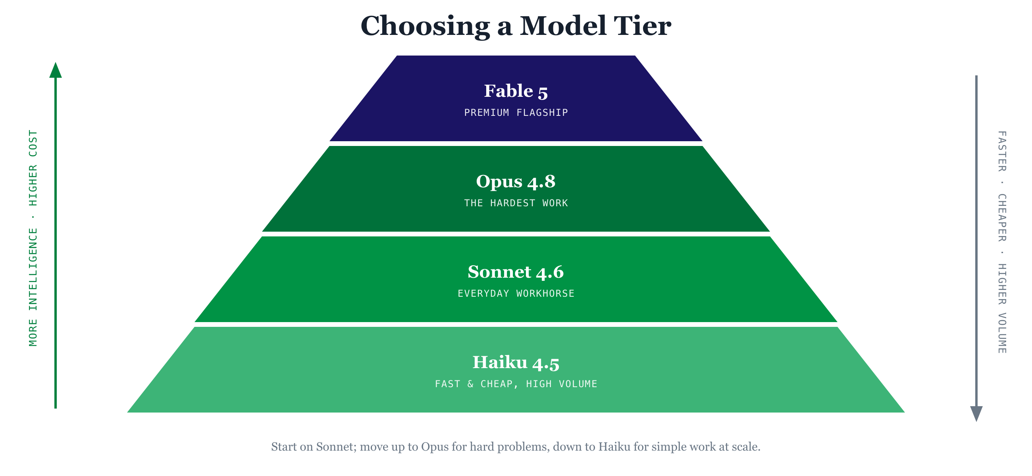

3.1 Choosing a tier
Tier | Best for | Speed | Cost | Intelligence
Opus 4.8 | The hardest work — complex reasoning, long multi-step agentic tasks, deep coding & research | Slower | Highest | Highest
Sonnet 4.6 | The everyday workhorse — drafting, summarizing, analysis, most coding | Fast | Moderate | Strong
Haiku 4.5 | High-volume, simple, speed-sensitive tasks — classification, quick lookups, bulk work | Fastest | Lowest | Good
As a rule of thumb, start on Sonnet for day-to-day work, move up to Opus when a problem is hard enough that quality matters more than speed, and drop to Haiku for simple work you run at high volume.

3.2 What the models can do
- Context window — how much Claude can hold in mind at once. Opus 4.8, Sonnet 4.6, and Fable 5 each have a 1-million-token window; Haiku 4.5 has 200,000 tokens.
- Adaptive thinking — Claude decides on its own how hard to reason — thinking longer on complex problems and answering directly on simple ones.
- Vision — all current models can interpret images: screenshots, charts, photos, and scanned documents.

3.3 The flagship: Claude Fable 5
Claude Fable 5 is Anthropic's most capable widely released model, sitting above the Opus tier for the most demanding reasoning and long-horizon agentic work, with always-on thinking and a 1-million-token context window. Because it is priced above the Opus tier, it is not an everyday default; save it for the hardest problems.

4. Claude Code: The TUI vs. the App
Claude Code is the same engine wherever you run it; what changes is the interface and the workflow around it. The question we hear most is how the terminal version (often called the TUI) differs from the desktop and web apps, so that is where we will start.

4.1 The terminal CLI (the “TUI”)
This is Claude Code run in your terminal with the claude command — a text-based interface (TUI) right where developers already work. It offers the full feature set: every slash command, inline diffs, session history, scripting and piping, and it runs anywhere a terminal does — locally, over SSH, in a container, or in CI/CD. It is the recommended starting point and the most flexible surface.

4.2 The desktop app & the web app
The Claude Code desktop app (macOS and Windows) and the web app at claude.ai/code wrap the same engine in a graphical experience and add capabilities that the bare terminal does not have:
- Parallel sessions in a sidebar — run several tasks at once, each isolated on its own git branch.
- Visual, click-to-approve diffs and an integrated editor and terminal.
- Background and cloud sessions — long-running tasks continue on Anthropic's servers even with your laptop closed; the web app needs no local setup at all.
- Mobile monitoring and scheduled/recurring tasks.
The terminal version is the lightweight option that runs anywhere and does everything; the apps add a graphical interface, parallel sessions, and cloud or background execution. Most developers end up using both.

4.3 IDE integrations
Claude Code also runs inside VS Code and the JetBrains IDEs (IntelliJ, PyCharm, WebStorm, and others) as an extension — a graphical panel with inline diffs, @-mentions of files, and a permission-mode selector, sharing your current editor selection and lint/type errors with Claude. The IDE extensions use the same CLI under the hood (install the standalone CLI separately to use the claude command in the IDE's terminal).
Surface | Interface | Stand-out strengths | Best when
Terminal CLI | Text (TUI) | Full features; scripting; SSH/CI; runs everywhere | Getting started; automation
Desktop app | GUI (Mac/Win) | Parallel sessions; background & cloud tasks; visual diffs | Many projects at once; long tasks
Web (claude.ai/code) | Browser | Zero setup; cloud sessions; mobile monitoring | No local setup; remote repos
IDE extension | VS Code / JetBrains | Inline diffs; selection & error sharing | You live in your editor

5. Permissions & Controls
Permissions cover two separate things. One is how much Claude Code can do on your machine without asking, set by its permission modes. The other is who on your team can administer your organization, set by admin roles. The sections below take each in turn.

5.1 Claude Code permission modes
Permission modes control whether Claude asks for approval before editing files or running commands. In the terminal, press Shift+Tab to cycle modes; in the apps and IDE extensions there is a mode selector.
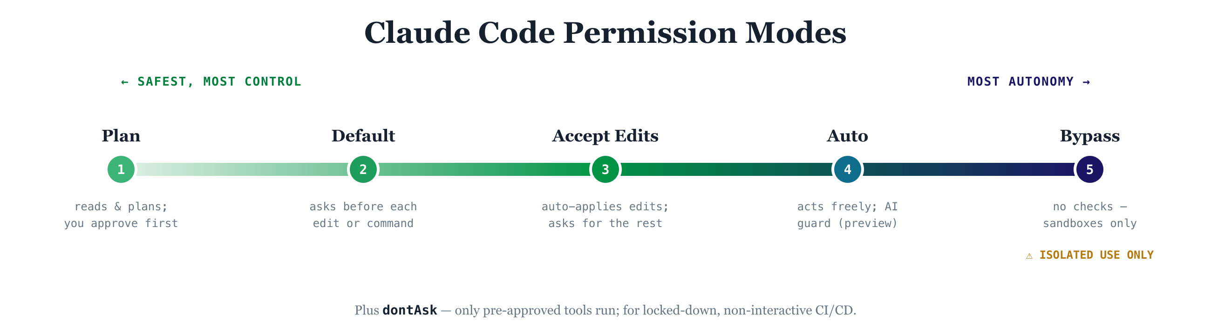
Mode | Auto-approves | Use for
default | File reads only — asks before any edit or command | Getting started; sensitive work (safest)
acceptEdits | File edits and safe filesystem commands | Iterating on code; review diffs after
plan | Reads only — explores and writes a plan, stops before changes | Exploring before committing to edits
auto | Most actions, with an AI classifier blocking suspicious ones | Longer tasks with fewer prompts (research preview)
dontAsk | Only pre-approved tools; everything else denied | Locked-down, non-interactive CI/CD
bypassPermissions | Everything, with no checks | Isolated containers/VMs only — risky elsewhere
Sensitive paths (such as .git/, shell dotfiles, and tool config files) are always protected regardless of mode. Allowlists in settings.json let you pre-approve specific commands so you are not prompted repeatedly.

5.2 Team & Enterprise admin roles
On Team and Enterprise plans, administrators manage the organization through built-in roles:
- Primary Owner — one per organization; full control, can manage all data and members.
- Owner — full access; with the Primary Owner, the only role that can change member roles.
- Admin — administrative access, which can be scoped/delegated on Enterprise.
- Member (User) — standard participant.
Role-based permissions let admins control which features and connectors specific groups can use, and delegate specific admin areas — Identity & Access, Billing, Analytics, Privacy, User Management, and Libraries — rather than granting blanket access. Enterprise additionally supports custom roles defined at the group level.

6. Plans & Pricing
Claude subscriptions range from a free individual tier to custom Enterprise agreements. The table below summarizes the consumer and business plans (all prices USD; this is the Claude.ai subscription pricing, separate from the per-token Claude API).

6.1 Individual plans
Plan | Price / month | Usage | Highlights
Free | $0 | Limited baseline | Chat, web search, file uploads, MCP connectors, extended thinking. No Claude Code or Cowork.
Pro | $20 ($17 annual) | Standard paid usage | Everything in Free + Claude Code, Cowork, unlimited Projects, multiple models, Research.
Max 5x | $100 | 5× Pro usage | Higher limits & output; priority access to newest models.
Max 20x | $200 | 20× Pro usage | Highest individual usage; priority during peak demand.

6.2 Business plans
Plan |  | Price / seat / mo | Minimum | Adds over the tier below
Team Standard |  | $25 ($20 annual) | 5 seats | Admin & billing tools, SSO + domain capture, role-based permissions, spend caps, enterprise connectors. Includes Claude Code & Cowork.
Team Premium |  | $125 ($100 annual) | 5 seats | Everything in Standard with substantially higher per-seat usage (5× a Standard seat).
Enterprise |  | Custom — contact sales | 20 (self-serve) / 50 (sales) | SSO/SAML, SCIM provisioning, audit logs, custom data-retention controls, HIPAA-ready (BAA), expanded context, analytics & compliance APIs, custom roles.
Verify before you commit
Enterprise pricing is custom; a per-seat figure sometimes shown publicly is best confirmed directly with Anthropic sales, and Enterprise usage is typically billed at API rates rather than a fixed allowance.
Inclusion of Claude Code on Team Standard is per Anthropic's Help Center; confirm with your account team, as some third-party summaries state otherwise.
Max plan prices are web-subscription rates; mobile app-store pricing may differ.

7. Getting Started

7.1 With Claude (chat) or Cowork
- Go to claude.ai (or install the desktop/mobile app) and create an account.
- Choose a plan — Free to try it, or Pro to unlock Claude Code and Cowork.
- Start a conversation, or open Cowork in the desktop app and describe a task to hand off.
- Connect tools (Google Drive, Slack, Microsoft 365) so Claude can work with your files.

7.2 With Claude Code (your first 15 minutes)
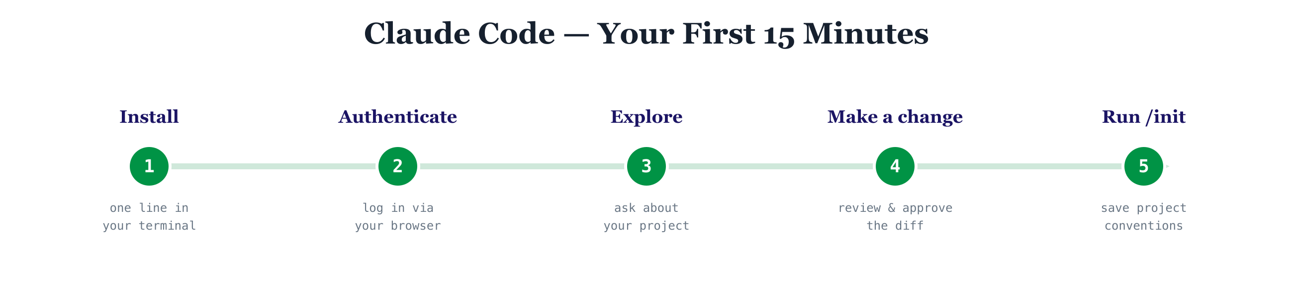
Install (macOS/Linux): curl -fsSL https://claude.ai/install.sh | bash — then run claude to log in through your browser (Claude subscription or API key). On Windows, use the PowerShell installer; Homebrew and WinGet packages are also available.
Stay in default permission mode while you learn: ask Claude about your project, make a small edit, then review and approve the diff. Finally, run /init to create a CLAUDE.md so Claude follows your project's conventions every session.

Handy first slash commands
Command | What it does
/help | List all available commands
/init | Create a CLAUDE.md describing your project for Claude
/mcp | Add and manage external tool integrations (MCP)
/review | Review code changes
/usage | Check your token usage
Shift+Tab | Cycle permission modes

8. Quick Decision Guide

8.1 Which product?
If you want to… | Use
Ask questions, draft, research, analyze — staying in the loop | Claude (chat)
Hand off a multi-step office task and get a finished deliverable | Claude Cowork
Build, edit, or maintain software across a codebase | Claude Code

8.2 Which model?
If the task is… | Choose
Simple and high-volume (classify, quick lookup) | Haiku 4.5
Everyday work needing a balance of speed and quality | Sonnet 4.6
Hard — deep reasoning or long agentic work | Opus 4.8
At the absolute frontier of difficulty (premium) | Fable 5

8.3 A recommended adoption path
- Start individuals on Pro to unlock chat, Cowork, and Claude Code in one plan.
- Move teams of five or more to a Team plan for central billing, SSO, and shared admin controls.
- Graduate to Enterprise when you need SAML/SCIM, audit logs, data-retention controls, or compliance commitments such as a BAA.
- Keep Claude Code in default or plan mode while learning; adopt acceptEdits and allowlists as trust grows.

9. Key Terms & Resources

9.1 A few terms you'll hear
Term | Plain-language meaning
Model | The underlying AI (e.g. Opus, Sonnet, Haiku) that generates responses.
Agent | Claude working autonomously across multiple steps to finish a task — the idea behind Cowork and Claude Code.
Prompt | What you ask or instruct Claude to do.
Token | The unit Claude reads and writes in (roughly ¾ of a word); usage and pricing are measured in tokens.
Context window | How much text Claude can consider at once — e.g. 1 million tokens on Opus and Sonnet.
MCP | Model Context Protocol — the standard that lets Claude connect to outside tools and data (Drive, Slack, GitHub, and more).

9.2 Official documentation & product pages
- Claude plans & pricing — claude.com/pricing
- Claude Cowork — anthropic.com/product/claude-cowork
- Claude Code documentation — code.claude.com/docs
- Claude Code permission modes — code.claude.com/docs/en/permission-modes
- Models overview — platform.claude.com/docs/en/about-claude/models/overview
- Roles & permissions — Claude Help Center (support.claude.com)
Figures and product details in this guide were current as of June 2026 and drawn from Anthropic's product pages and Help Center. Pricing and feature availability change frequently — confirm current terms at claude.com/pricing and with your Anthropic account team before making purchasing decisions.

727 MADISON AVENUE, COVINGTON, KY 41011 · (859) 414-1915 · INFO@SYRV.AI

